Water Resources Suitability Model by Using Geographical Information System (Case Study: Borujerd Rangeland, Sarab Sefid)

Marzieh Asgari1*, Golnaz Kheradmand2, Elahe Karami3, Fazel Amiri4
¹ Assistant Prof., Borujerd Branch, Borujerd, Lorestan, Iran, *(Corresponding author), E-mail: asgari@iaub.ac.ir
² Associate Prof., Academic Center for Education, Cultural and Research, Kermanshah, Iran
3 M.Sc. Student, Department of Rangeland Management, Young Researchers Club, Borujerd Branch, Tehran University, Borujerd, Iran
⁴ Full Prof., Faculty Member, College of Engineering, Booshehr Branch, Booshehr University, Iran

Abstract:
Water resources suitability is one of the most important factors to sustainability utilization of natural potential by rangeland grazing suitability. To determine this factor in short time, low cost and high accuracy are most challenges of experts and ranchers. Using suitable technique for this subject can be sustainable utilization comprising from rangeland ecosystems according to its degradation and heavy grazing. This research was conducted in Borujerd Sarab Sefid rangeland, Lorestan province, Iran from 2011 to 2012. Some factors such as slope, height and direction maps provided by using satellite images, basic information, analog and digitized maps such as; topographic and DEM (Digital Elevation Model). Also measurements of field were conducted by excursion and interview with herders to determine places of water resources such as permanent and temporary springs and permanent and temporary rivers too. Water resources area's map was prepared by using Arc GIS9.3 software with integration of digitized information and field data. At the end water resources suitability were determined by using three sub models such as quantity, quality and distance from water resources. Results show that all of 16 plant vegetation types were dropped in І and П classes of water resources suitability which didn’t have any limitation according to quantity and quality and distance of animal husbandry and livestock. As a final conclusion this research shows that using RS and GIS could be useful to water resources suitability of rangeland ecosystems with low cost and high accuracy and speed, if consider standards and criteria of using GIS and RS.

Key words: Sustainable utilization, Satellite images, Grazing, Natural potential

Introduction
Rangeland ecosystem correct management needs recognizing water, soil and plant resources, which are basic resources for production. Correct programming for suitable utilization from those not only decrease rangeland degradation but also cause conservation and improvement of those. Thus, one of the most important factors and also difficult in analysis and evaluation of rangelands is utilization based on those potential and abilities. Recognition of factors affect those, and have special importance to desirable use and suitable management of rangeland. One of the main problems of developing countries such as Iran is utilization of natural resources area without ecological situation and its potentials consequently destruction of soil, water and plant as the most significant basis of suitable production. Most area of Zagros mountains include rangelands which most of them have not suitable quality and quantity forage, also access to water resources, cause more erosion for requirement of providing water and forage of livestock. These factors affected by rangeland utilization history (Moghadam, 1998). FAO guided a standard evaluation system for assessment of land. In 1972 prepared its background and in the next year wrote the first format then final format of land evaluation issued in 1976 by FAO. Subsequent issued guides of land evaluation for different land uses such as dry farming (FAO, 1993), forestry (FAO, 2007), dryland farming cultivation (FAO-UNDP, 1985) and expanded grazing (FAO, 1991). On the first hand suitable uses and land resources balancing is needed, more information and its utility to different systems relevant to the earth such as natural resources and on the second hand nature of dynamic and those changeable, make human to use new methods and electronically instruments (Makhdom, 2001). RS and GIS methods are the new sciences as well as nano technology that are vastly used in natural science (Malczwski, 1990). Suitable utilization of rangeland need to recognize its parameters, therefore determination of rangeland suitability is one of the most significant factors and more difficult to rangeland analysis (Mohtashamnia, 2000). To determine livestock grazing suitability some factors such as plant cover properties, topography, pedology, climate, geology, geomorphology, sediment and erosion, rivers network, water resource must be investigated. Be careful that all factors of ecosystem have role in animal grazing and there is no possibility to recognize all of them, so recognition of the most important factors and selecting them to use by abilities of geographical information system to decrease time and increase accuracy for preparation of information layers and integrating them is necessary. The kind of animal which use rangeland can be different according to physical factors such as slope, dimension of range, natural barriers, water resource spreading, soil properties, soil sustainability, soil sensitivity to erosion, percent of plant coverage, soil coverage and forage production (Moghadam, 1998). 70 percent of Iranian livestock rely on rangeland, so for better using of rangeland potential investigation of limitation and none limitation of animal grazing in rangeland suitable determination is needed, which one of them is water resource, therefore Borujerd Sarab Sefid regions are selected according to the number of livestock like sheep. Beside using rangeland forage for grazing of livestock there must be enough water to drink during grazing season that cause the maximum using of forage by livestock for producing animal products (Schacht et al., 2003). In some cases there is enough water but its propagation is not good, therefore animal cannot use all of the forage in rangeland (Scarlett, 2002). In fact it is important to provide enough water for drinking livestock and wildlife. As a general rule one of the effective factors in site selection of grazing is water distance (Lotfollahzadeh, 1999). Livestock and wildlife very often graze plants in the vicinity of water (Bailey, 2004). When water is the most significant limited factor for using forage, it affects on animal movement. So it is important for management of rangeland to find distance of animal to water resource which must cover the distance and amount of forage uses in the course of movement (Vallentine, 2001). Generally access ability to water resource depends on maximum distance where livestock can be far from water resource to forage grazing. The distance depends on topography, utilization season, age and kind of animal and plant coverage (Arnold and Dudzinaski, 1995). Several factors affect on water consumption such as kind, age and breed, topography, quality and quantity of forage accessibility, grazing season and distance from water (Bagley et al., 1997). Water with more salinity or with poisonous elements may endanger animal health or make meat and milk uneatable. Also water with unsuitable quality affect on forage productivity. To determine usable water we must consider area situation, age and breed of animal and nutrition composition (Mahdavi, 1999). In fact animals prefer to drink fresh water (Moghadam, 1998).
The aim of this study was conducted to use geographical information system in preparing water resource sustainable model to animal based on FAO method (1991), and rangeland uses ability to animal grazing in terms of suitable uses of these lands based on water resources existing.

Materials and Methods
Study area
Sarab sefid rangeland in question is located in west of Borujerd city in Lorestan province, Iran (48º 27´ 46˝ to 48º 36´ 30˝ E and 31º 53´ 33˝ to 33º 58´ 24˝ N) comprises of 5864 ha (58.6 Km²) which is 3.78% of Borujerd city (Figures 1 and 2). The average of annual precipitation (20 years) of the area is 450.9 mm, falling mainly in the autumn and winter. The average minimum and maximum temperatures are 11.5ºC and 39.2ºC, respectively. Its climate based on Henry Pabo (Senior expert of FAO) is located in Iran-Toran (High Mountain Region). The average height at the sea level is 2744 m and the minimum and maximum are 1947 and 3451 m, respectively. In this basin there is one village under the title of Venaii (Figure 3).

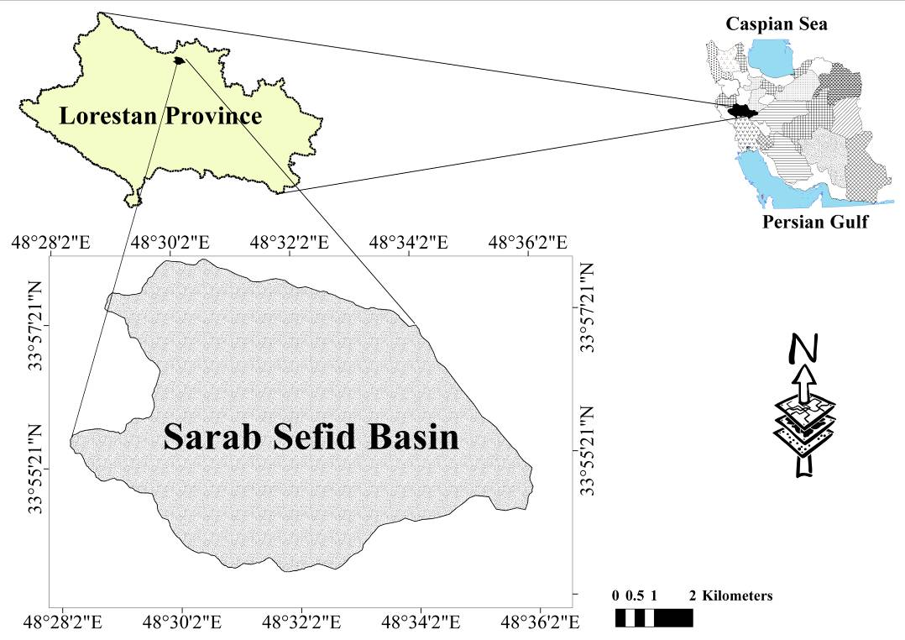
Figure 1. The location of the study area, Sarab Sefid basin
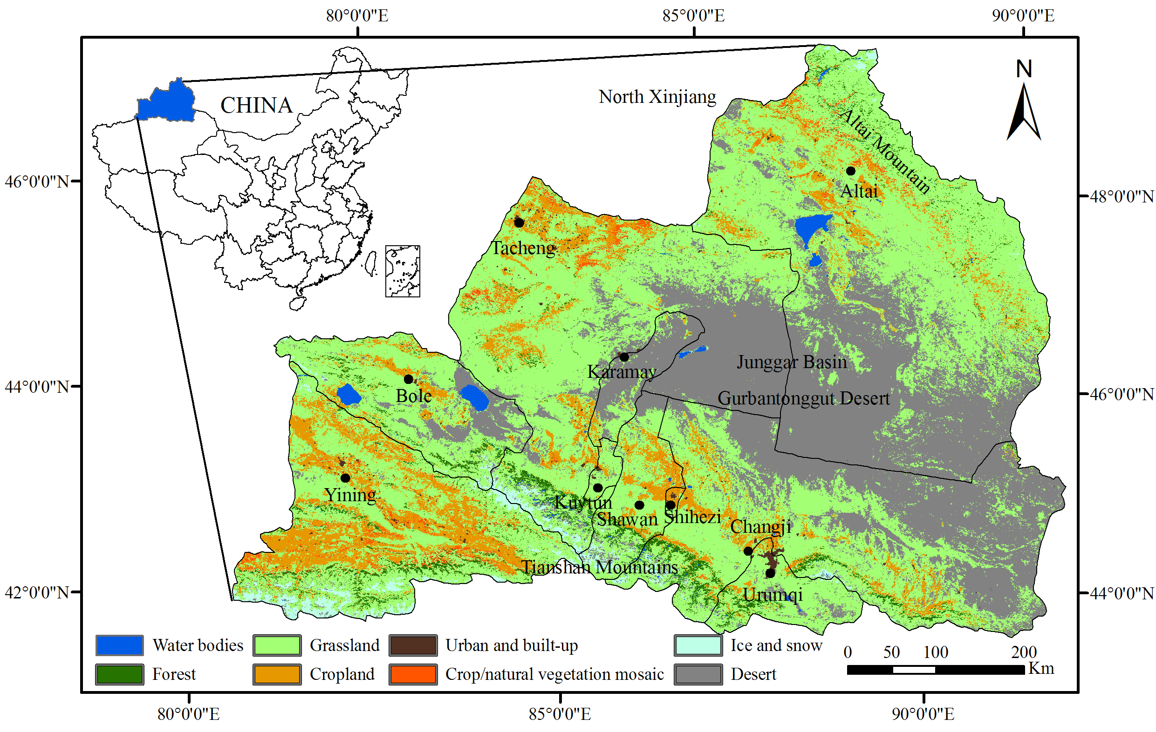
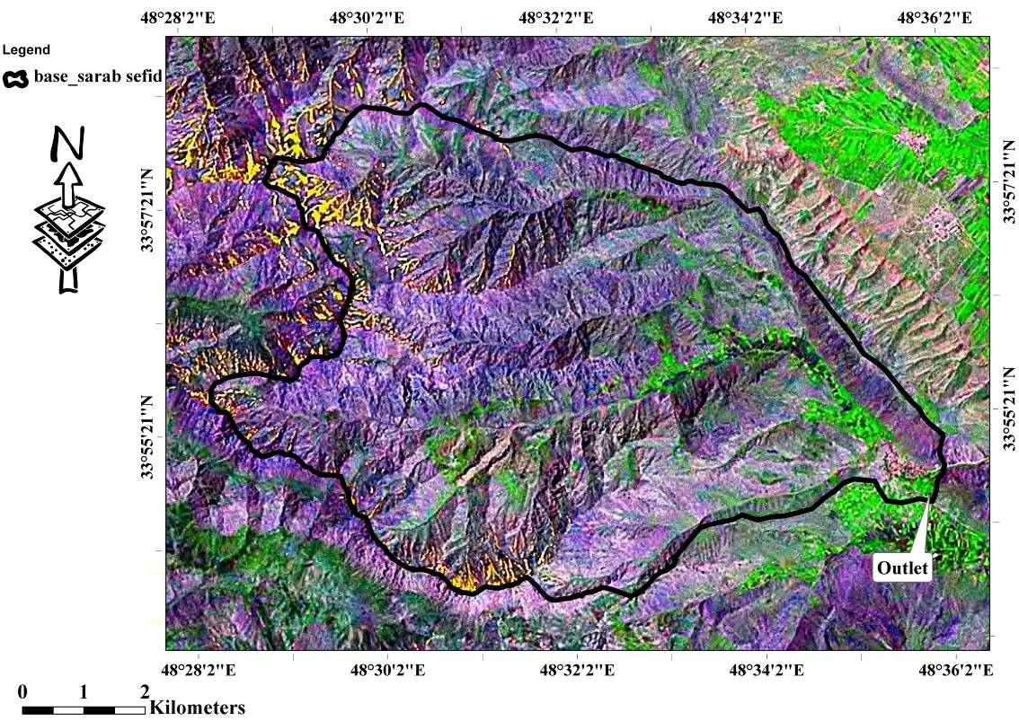
Figure 2. Satellite imagery of Sarab Sefid basin

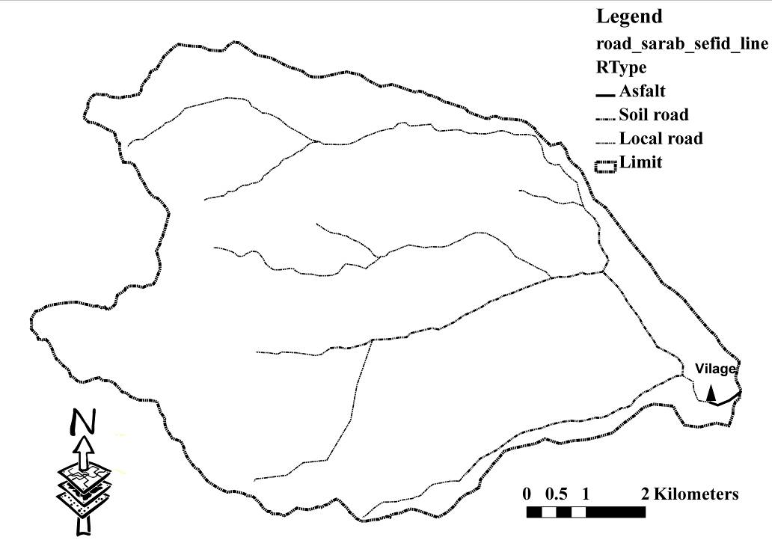
Figure 3. The location of the Venaii village in the area and accessibility ways

Water resources of the area
There is one permanent river in the basin in form of a spring which its name is Sarab sefid, which divided into, too many main watercourses and secondary one. Its direction is from south west to north. Also there are many permanent and seasonal springs in the area. To determine contour distance map from water resources first, distance from water resources map was prepared (Figure 4).

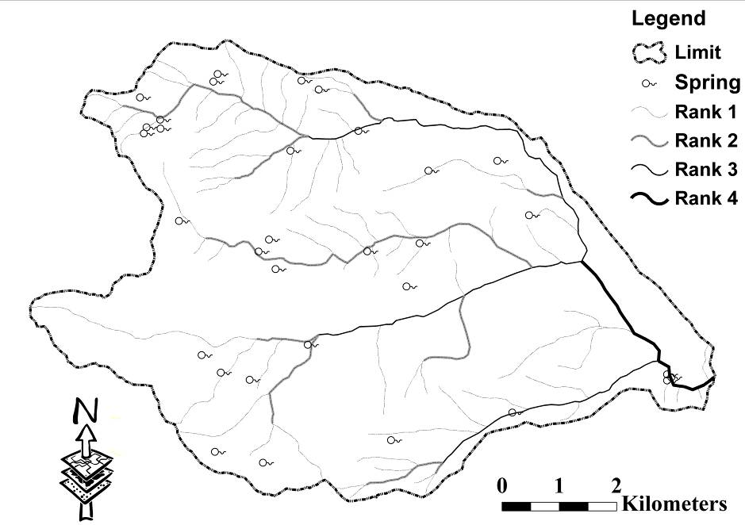
Figure 4. The map of basin hydrological networks and springs

Criteria of water resources suitability
The model make up of three sub model that is water resource distance, quality and quantity. According to these sub models in each types of rangeland and combine them together, water resource suitability in the area for sheep grazing determined (Figure 5).
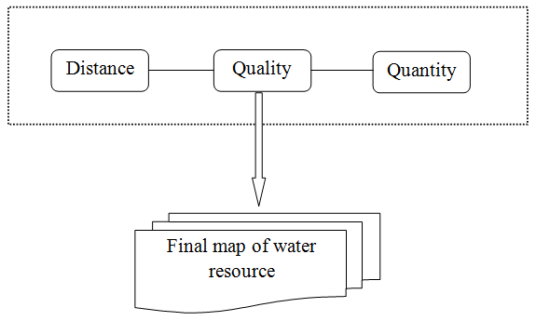
Figure 5. The final model of water resources suitability for sheep grazing

Water resources model
The water resources suitability consists of three sub-models which include: water remoteness, quality and quantity. In this study, location, quantity, quality and remoteness of water resources in each traditional boundary was determined (Figure 5).

a) Water accessibility sub-model
First, the slope maps of the study areas were classified and water remoteness in each slope class was calculated and the related map was extracted by using Arc GIS 9.3. Overlaying both maps led to the final water accessibility model. The distance from water resources suitability classes in livestock usage are illustrated in Table 1.

Table 1. Water resource distance and its suitability classes (Yoosefi khangah, 2004)
Suitability class |  | Slope class (%)
 | 0-10 | 10-30 | 30-60 | >60
S1 | 0-3400 | 0-3000 | 0-1000 | N
S2 | 3400-5000 | 3000-4800 | 1000-3600 | N
S3 | 5000-6400 | 4800-6000 | 3600-4100 | N
N | >6400 | >6000 | >4100 | N

b) Water quantity sub-model
In this step, the location and discharge of water resources were determined and summed up within each types of plant boundary to calculate water availability. Comparing animal water demand and available water, results in the water quantity suitability sub-model. According to climatic conditions, vegetation characteristics, grazing season and animal type, animal water demand was estimated by using (Equation 1).
a l/kg 0.82 /day =? lit /day (Equation 1)
Where
a= the coefficient which is to be calculated based on local investigations,
‘?’ = the amount of water needed by the livestock,
kg =the live weight of the livestock on the kilogram basis
The suitability categories were then determined by comparison of the available water with the water needed by the livestock (Table 2).

Table 2. Water resource suitability classes
Available water in pasture ration to livestock need (%) | >76 | 51-75 | 26-50 | <25
Suitability classes | S1 | S2 | S3 | N

c) Water quality sub-model
In this study, water quality data of water resources [pH, EC, Total Dissolved Salts (TDS), Na, Cl, Co₃, Mg, SO₄, Ca, Total Hardness (TH), S.A.R, K⁺, Mg²⁺ and NO3] were acquired from local offices, Lorestan water management and other researches and compared with standards to determine water quality suitability. Finally these three sub-models were integrated to make the final water resources suitability model for extensive grazing (Figure 6).

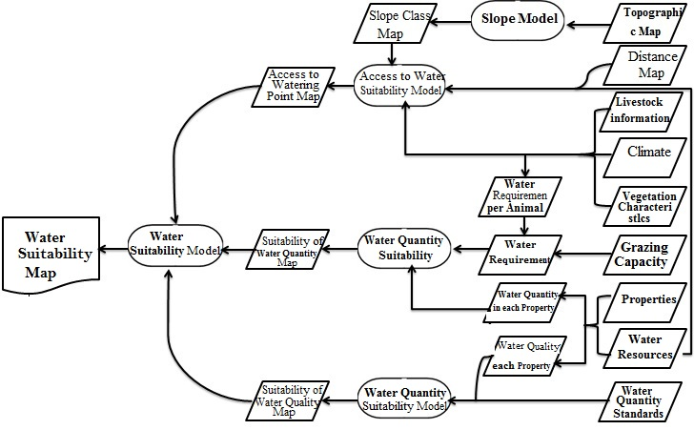
Figure 6. Model for classification of water resources suitability

Factors rating
A factor is usually rated in terms of four classes with critical values attached to it, as follows (Table 3). Based on the suitability classes of each factors for each objective, the final land suitability map was given from N (unsuitable) to S1 (most suitable).

Table 3. Factor rating of land characteristics (FAO 2002, 1991)
Order | Class | Description
Suitable (S) | S1 (Highly suitable) | Land having no, or insignificant limitations to the given type of use
Suitable (S) | S2 (Moderately suitable) | Land having minor limitations to the given type of use
Suitable (S) | S3 (Marginally suitable) | Land having moderate limitations to the given type of use
Not Suitable (N) | N (Unsuitable) | Land that have so severe limitations that are very difficult to be overcome

Results
In this study, a model of water resources suitability assessment for grazing of Sarab Sefid rangeland in Iran was elicited. Based on previous studies and field experiences, three limited conditions for grazing (FAO, 1991) were taken into account. A model was proposed for each given criteria.

Suitability model of water resource

a) Suitability model of water resources quality
The suitability categories of this model were determined by using the combination of three criteria such as quality, quantity and distance from water resources (Figure 5). Based on the water resources quality and considering the water quality, there were no limitation in the range area in question, and the whole range area fell within the S1 suitability category. Results show that Total Hardness (TH) based on standard is good for sheep. Also these results are similar to Cl, pH (7/8), NO3 (4/4), EC (235mimhos per cm), TDS (140/8 mg/lit) and other factors except SO₄. For the last factor (SO₄) there is a little limitation for drinking by sheep.

b) Suitability model of water resources quantity
The results revealed that there were no limitations for the amount of water in the region, so all of them fell into the S1 suitability category, because of high precipitation of the region which is between 500 to 700 mm per year (annually) and it has good intensity during year. In mountain and high elevations precipitations are most as snow and cause to save it, and its result is producing spring in the basin which is suitable water quantity for sheep as Loree local breed. In this basin there is enough water during grazing season for livestock and wildlife and it is more than water needed based on determined grazing capacity.

c) Distance from water resources suitability
The results of the sub-model on the distance from water resources suitability revealed that 4960 ha of the rangeland area (84.58%) fell in the S1 suitability category and 904 ha (15.42%) of the rangeland of the region in question fell into the S2 suitability category, in addition, no rangeland area fell into the S3 and N suitability category (Table 4).

Table 4. Area and percent of categorization of distance form water resources suitability
Area (%) | Area (ha) | Categorization of Suitability
84.58 | 4960.02 | S1
15.42 | 904.20 | S2

Final water resources suitability
In this basin 16 plant vegetation types were determined based on field data (Table 5). The final outcome of the model on water resources is illustrated in Table 6. The region in question had no problems regarding the quantity and quality of the water resources; it was only the distance from the resources that mainly determined the suitability of the rangeland with respect to water resources (Figure 7).

Table 5. Types of plants in the basin and amount of area’s types
Percent of all | Area (hec) | Abbreviation | Type Name | Code
7.10 | 416.48 | Ga-Fa | Garden-Farm land | 1
18.66 | 1094.09 | As.ad-Er.no | Astragalus adscendens-Eryngium noeanum | 2
16.54 | 969.80 | As.ad-Er.no | Astragalus adscendens-Eryngium noeanum | 3
4.46 | 261.27 | As.mi-An.gr | Astragalus microcephalus–Annual grass | 4
3.51 | 205.67 | As.mi-An.gr | Astragalus microcephalus–Annual grass | 5
3.52 | 206.19 | As.mi-Co.ja | Astragalus microcephalus-Cousinia jacobsii | 6
8.38 | 491.37 | As.mi-Co.ja | Astragalus microcephalus-Cousinia jacobsii | 7
9.10 | 533.49 | As.mi-Co.ja | Astragalus microcephalus-Cousinia jacobsii | 8
2.08 | 122.06 | As.mi-Me.pe | Astragalus microcephalus -Melica persica | 9
2.50 | 146.56 | As.mi-Me.pe | Astragalus microcephalus -Melica persica | 10
2.40 | 140.91 | As.mi-Me.pe | Astragalus microcephalus -Melica persica | 11
4.59 | 269.35 | As.mi-Rh.co | Astragalus microcephalus-Rhus coriaria | 12
6.16 | 361.35 | Ho.bu-As.mi | Hordeum bulbosum-Astragalus microcephalus | 13
5.59 | 327.60 | Ho.bu-As.mi | Hordeum bulbosum-Astragalus microcephalus | 14
1.99 | 116.75 | Ho.bu-As.mi | Hordeum bulbosum-Astragalus microcephalus | 15
3.43 | 201.29 | Ho.bu-As.mi | Hordeum bulbosum-Astragalus microcephalus | 16
100 | 5864 | Total

Table 6. Categorization of land area into suitability classes based on water resources model in each type of plants in the study area
Water Resource Suitability | Percent | Area (ha) | Type Sign | Abbreviation | Code
S2 | 7.10 | 416.48 | G | Ga-Fa | 1
S2 | 18.66 | 1094.09 | E1 | As.ad-Er.no | 2
S2 | 16.54 | 969.80 | E2 | As.ad-Er.no | 3
S2 | 4.46 | 261.27 | F2 | As.mi-An.gr | 4
S1 | 3.51 | 205.67 | F1 | As.mi-An.gr | 5
S2 | 3.52 | 206.19 | B1 | As.mi-Co.ja | 6
S1 | 8.38 | 491.37 | B2 | As.mi-Co.ja | 7
S2 | 9.10 | 533.49 | B3 | As.mi-Co.ja | 8
S1 | 2.08 | 122.06 | D2 | As.mi-Me.pe | 9
S2 | 2.50 | 146.56 | D3 | As.mi-Me.pe | 10
S1 | 2.40 | 140.91 | D1 | As.mi-Me.pe | 11
S2 | 4.59 | 269.35 | C | As.mi-Rh.co | 12
S2 | 6.16 | 361.35 | A1 | Ho.bu-As.mi | 13
S1 | 5.59 | 327.60 | A2 | Ho.bu-As.mi | 14
S1 | 1.99 | 116.75 | A4 | Ho.bu-As.mi | 15
S1 | 3.43 | 201.29 | A3 | Ho.bu-As.mi | 16

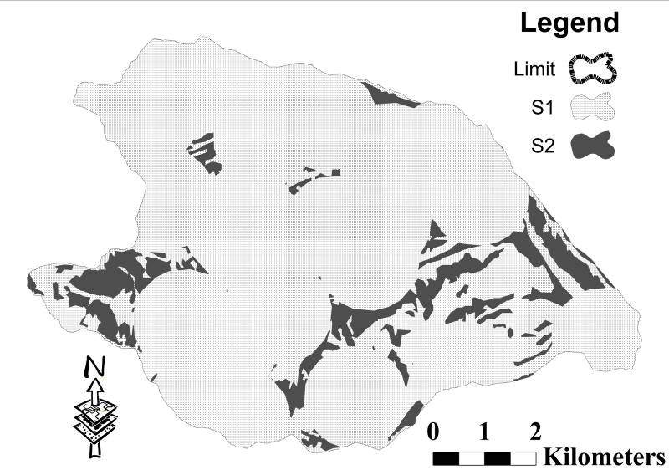
Figure 7. The final model of water resource suitability
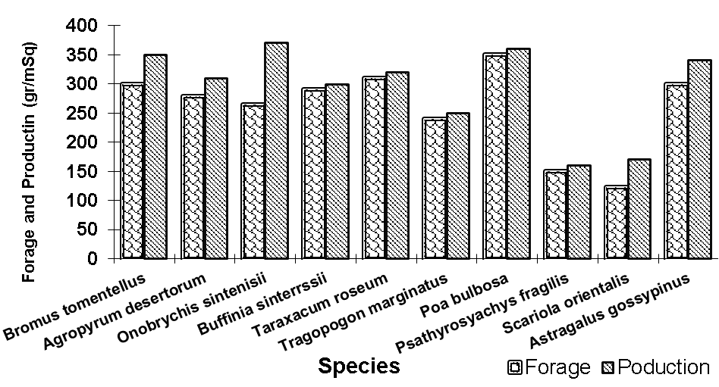

Discussion
In Iran, as in most parts of the world, animal husbandry is the most productive use of Zagros Mountains in Iran. Keit (2000) showed that for determining water resource suitability for cattle grazing assessment factors such as slope, number of water resources, steep slope and suitable distance from water resource are needed and he explained that, these are significant factors in spreading and suitability which the present study reach the similar results. In studies of Jangjoo Borzelabadi (1996), Mohtashamnia (2000), Yoosefi khanghah (2004), Arzani and Yoosefi (2006), to determine animal grazing suitability carried out three factors such as forage production, water resource and soil sensibility based on FAO (1991) method that the present research path same method and showed same results. Minor (2002) for determining rangeland grazing capacity of Fergosen-California region used RS and GIS abilities. He applied three sub-models such as plant cover, slope and precipitation for determination of final model of grazing capacity and declared that the results by GIS had acceptable accuracy for management of rangeland. The results are based on Paul Tueller and Reno Nevada (2001) opinion for using RS technique to investigate rangeland forage production. The results of the study showed that the quantity (number of permanent water resources), quality and the distance from the water resources did not impose many limitations on the rangelands suitability for grazing livestock. However, the steep slopes along the livestock path to the water resources resulted in the formation of an ‘unsuitability’ category for livestock. Valentine reported on the importance of the slope factor in reaching the water resources, and declared that by increasing the slope the ability to graze decreases and increases the livestock demand to expend lots of energies. The quality and quantity of the water resources in the rangeland did not impose any limitations. The result of the research indicates the slope as the reducing and sometimes limiting factor in the range suitability. Hence, the slope factor is of considerable importance in determining the suitability of the pasture for grazing. As slope increases the water retention time on the ground decreases, the rate of penetration decreases, and the amount of water run-off increases. Cook explained that on slopes of more than 60 degrees little forage is grazed. Amiri and (Gavili et al., defined the slopes with more than 60 percent as useless for all kinds of livestock, while (Holechek et al., reported slopes of more than 60 percent, and (Arzani et al., defined slopes of more than 60 percent as useless for livestock grazing. On such steep slopes wild animals would graze better than livestock. (Guenther et al., in determining the suitability of a rangeland in Australia noted the two factors of slope and water resources as the suitability limiting factors of rangeland for grazing cattle. Due to the existence of numerous permanent water resources in Sarab Sefid rangelands, the water resources factor does not impose many limitations on the suitability of the rangeland. However, the slope factor in reaching the water resources in limited areas of the rangeland was a suitability limiting factor. It must be noted that the results reported by (Guenther et al., was similar to that observed in the present study.

Conclusion
In this research, recent developments of using GIS as a smart tool in supporting the ranchers and pasture owners for monitoring land suitability for livestock feeding purposes was challenged. This study showed that water resources are unlimited factors for livestock grazing. As FAO argues, different land units have different qualities for certain utilizations.

Acknowledgment
The authors gratefully acknowledge the financial support for this work that was provided by University.

References
Amiri, F., 2009. A GIS model for determination of water resources suitability for goats grazing. African Journal of Agricultural Research, 4(1): 014-020.
Arnold, G.W. and Dudzinaski, M. L., 1995. Ethology of free ranging domestic animals. 1edn. Amsterdam: Elsevier Science, Publication, Co, USA. 51-55 pp.
Arzani, H., Jangjo, M., Shams, H., Mohtashamnia, S., Fashami, M., Ahmadi, H., Jafari, M., Darvishsefat, A., Shahriary, E., 2006. A model for classification of range suitability for sheep grazing in Central Alborz, Ardestan and Zagros regions. Journal of Science and Technology of Agriculture and Natural Resources, 10(1): 273-290. (In Persian).
Arzani, H. and Yousefi. S., 2006. A GIS model of range suitability assessment for sheep grazing (Case study Taleghan Region in Tehran Province). 8th International Conference on: Information Systems in Sustainable Agriculture, Agro-environment and Food Technology, 20-23 September. Thessaly. 911-918 pp. (In Persian).
Bagley, C. V., Amacher, J. K. and Kitt, F. P., 1997. Analysis of water quality for livestock. Utah State Extension, Animal Helth Fact sheet, Utah State University, Logan UT 84322-5600. Electronic Publishing, 7 pp.
Bailey, D. M., 2004. Management strategies for optimal grazing distribution and use of arid rangelands. Journal of Animal Science, 82 (E. Suppl.): E147–E153.
Cook, C.W., 1954. Common use of summer range by sheep and cattle. Journal of Range Management, 7(1):10-13
FAO., 1976. A framework for land evaluation. Food and Agriculture Organization of the United Nations, Soils Bulletin 32. FAO, Rome.
FAO., 1991. Gudelines: Land evaluation for extensive grazing. FAO Soils Bulletin No. 58. FAO, Rome, Italy. 170 pp.
FAO., 1993. Gudeline for land use planning. FAO Development Series, No: 1, FAO, Rome, 96 pp.
FAO., 2002. Agricultural drainage water management in arid and semi-arid areas. Food and Agriculture Organization of United Nations., Rome.
FAO., 2007. Land evaluation towards a revised framework .Food and Agriculture Organization of the United Nations., Rome, Italy.
FAO-UNDP and UNEP., 2007. Land degradation in south Asia: its severity, causes and effects upon the people. World Soil Resources Report, No. 78. FAO, Rome, Italy. 100 pp.
Gavili, E., Ghasriani, F., Arzani, H., Vahabi, M. and Amiri, F., 2011. Determine water resources accessibility for sheep grazing by GIS technology (Case study: Feraidun Shahr rangeland in Isfahan Province). Journal of Applied RS and GIS Technology in Natural Resource Science, 1(1): 89-99. (In Persian).
Guenther, KS., Guenther, GE., Redick, PS., 2000. Expected-use GIS maps. Rangelands, 22(2):18-20.
Holechek, J. L., Pieper, R. D., Herbel, C. H., 1995. Range management: principles and practices. 2nd edn. Prentice-Hall, USA.
Jangjoo Borzelabadi, M., 1996. Determination of rangeland suitability by using GIS. M.Sc. Thesis, natural resource faculty, Tehran university, Iran. (In Persian).
Kiet, S., 2000. Expected use GIS map. Rangeland, 22(2): 18-20.
Lotfollahzadeh, D., 1999. Relation between the spatial and temporal patterns of rangeland condition/flock movement and soil properties. M.Sc. thesis, ITC, Enschede, The Netherlands.
Mahdavi, M., 1999. Application hydrology. Second edition, Tehran university press, Iran Pages: 400. (In Persian).
Makhdom, M., 2001. Evaluation of environment by GIS. First edition, Tehran university press, Iran, Pages 298. (In Persian).
Malczwski, J., 1990. GIS and Multi criteria decision analysis, John Wiley and sons Ins. Canada.
Minor, T., 2002. Range land evaluation in Freson County, California, based on livestock carrying capacity modeling using GIS, Proje : County of freson, California and Agricast, Inc.
Moghadam, M. R., 1998. Range management. First edition, Tehran University Press, Pages 470. (In Persian).
Mohtashamnia, S., 2000. Determination of rangeland suitability in semi steppe region of Fars province by GIS. M.Sc. Thesis, natural resource faculty, Tarrbiat Moddares university, Tehran, Iran. (In Persian).
Paul, G., T. Tueller. and Reno Nevada., 2001. Remote Sensing of Range Production and Utilization. Journal of Range Management, 54: A77-A89.
Scarlett, T., 2002. Drought feeding of goats. New South Wales Agriculture: Sydney. http//www. agric. nsw. gov. u/reader/5337 22/11/02.
Schacht, W. H., Volesky, J. D. and Waller, S. S., 2003. Proper livestock grazing distribution on range land. Published by Cooperative Extension, Institute of Agriculture and Natural Resources, University of Nebraska-Lincoln.
Vallentine, J. F., 2001. Grazing management. Academic Press, San Diego, CA.
Yoosefi khangah, Sh., 2004. Determination of rangeland suitability by using GIS. M.Sc. thesis, Natural resources faculty, Tehran University, Iran. (In Persian).

- Food and Agricultural Organization
- Remote Sensing
- Geographical Information System

