Original Research  Received:  07 May 2025  Accepted:  26 October 2025  Published in Issue:  31 December 2025 | Abstract  Motivation constitutes one of the key factors underlying language teachers’ professional performance. It exerts a considerable influence on their pedagogical efficacy and is likely to determine their resilience across various language contexts and academic settings. The present study scrutinized the main factors among German and Iranian English teachers’ motivation. Furthermore, it examined the difference between the motivation of these teacher groups. To this end, the researchers used convenience sampling to select 281 German and 231 Iranian English teachers as the participants. Moreover, they used four reliable and valid questionnaires to examine these participants’ teaching motivation, teaching enjoyment, emotion regulation, and work engagement. Lastly, they analyzed the obtained data using structural equation modelling and t-test. The results of the study indicated that German teachers’ teaching enjoyment and work engagement were the main factors in their motivation. On the other hand, Iranian teachers’ emotion regulation and work engagement were the significant predictors of their motivation. Furthermore, German teachers’ motivation was significantly higher than that of Iranian teachers. The results of the study are likely to provide guidelines on the development of education courses and manuals for English teachers in foreign language contexts.  Keywords: German English teachers; Iranian English teachers; teacher factors; teaching motivation
© 2025 the Author(s). Published by the OICC Press under the terms of the CC BY 4.0, Creative Commons Attribution License, which permits use, distribution and reproduction in any medium, provided the original work is properly cited.
Cite this article: Ahangaran, F., Pouyan, A., A Structural Equation Modelling Analysis of Factors Influencing Teaching Motivation among German and Iranian English Instructors , J. Engl. Lang. Pedagog. Pract., 18(2) Article 17 (2025). doi.org/10.57647/jelpp.2025.1802.17

Introduction

A careful review of the recent studies of language teachers (e.g., Alexander et al., 2020; Bing et al., 2022; Buric et al., 2020; Xiao et al., 2022; Xiyun, et al., 2022; Yang et al., 2022) indicates that they have focused on teacher factors in different academic settings. Chang and Taxer (2021) defined teacher factors as all of the teacher-internal variables that are likely to have a noticeable effect on language teachers’ mental health, coping, and pedagogical efficacy in the context of the classroom. Likewise, Deng et al. (2022) stated that these factors encompass language teachers’ affective features that affect their language teaching practices by influencing their psychological composure. As they noted, among these factors, Teacher Motivation (TM) has been a recurrent variable in numerous empirical studies.
Skaalvik and Skaalvik (2020) defined language teachers’ TM as the reasons behind their decisions to engage in language instruction in various academic settings. Similarly, Roth et al. (2007) pointed out that TM encompasses all of the factors that prompt the language teachers to take advantage of efficacious instructional strategies and techniques for ameliorating their learners’ acquisition of diverse aspects of the second language. As they explained, the widespread interest in language teachers’ TM stems from the fact that it is likely to influence all of the aspects of teachers’ pedagogical choices including their choice of instructional approaches along with their language teaching strategies and practices in their classes. They concluded that TM is an affective factor that can be influenced by teachers’ affective and personal variables.
Yuan and Zhang (2017) stated that among the various teacher factors, language teachers’ Teaching Enjoyment (TE), Emotion Regulation (ER), and Work Engagement (WE) (which will be explained in detail in the following section) have attracted attention as the affective variables that may influence their TM. They concluded that there is a need for more research on language teachers’ TM in different language learning contexts.

Background Studies

The examination of the recent research on teachers’ variables (e.g., Alexander et al., 2020; Skaalvik & Skaalvik, 2020) indicates that language teachers’ TM has attracted considerable attention in language education. Roth et al. (2007) defined TM as the totality of the factors that motivate language teachers to adopt effective instructional practices to enhance learners’ acquisition of the target language. The above-mentioned definition highlights the fact that various factors are likely to affect teachers’ tendency to engage in second language instruction (Alexander et al., 2020). Considering this issue, Roth et al. (2007) identified four main sub-categories of language teachers’ TM including intrinsic, extrinsic, identified, and introjected sub-components. As they explained, teachers’ intrinsic motivation refers to their interest in language instruction that is not influenced by the external rewards. On the other hand, extrinsic motivation encompasses teachers’ tendency to engage in language teaching in order to achieve a certain objective or to win an external award. Moreover, identified motivation refers to the extent to which teachers are cognizant of the advantages of language instruction before engaging in it. Lastly, introjected motivation encompasses teachers’ internal desire to teach the target language that results in their tension when they are not able to teach the language in an effective way. Roth et al. (2007) concluded that teachers’ TM is likely to be affected by their TE, ER, and WE among the other affective factors.
Dewaele and Li (2022) stated that TE constitutes an affective factor that determines the extent to which language teachers derive satisfaction from their language instruction and make an effort to perform their academic tasks in an efficacious way. In line with this definition, Proietti Ergün and Dewaele (2021) itemized three main sub-components of TE including social enjoyment, personal enjoyment, and learner appreciation. As they explained, social enjoyment refers to the satisfaction that teachers derive from development of working relationships with their peers and students. Furthermore, personal enjoyment specifies the extent to which target language instruction ameliorates teacher’ perspectives on their own pedagogical capabilities. Finally, learner appreciation refers to teachers’ positive feelings that stem from their learners’ understanding of their vital role in the context of the classroom.
In addition, Li et al. (2022) noted that language teachers’ ER constitutes an affective variable that determines their stress-management capability in their classes. Accordingly, they defined ER as teachers’ ability to stifle their negative emotions by capitalizing on their internal resources. Based on the nature of teachers’ ER, Gross and John (2003) itemized two main sub-components of this construct including cognitive reappraisal and expressive suppression. They explained that, teachers’ cognitive reappraisal refers to their ability to reassess various teaching conditions to ameliorate their perspectives on them. Moreover, as they noted, expressive suppression determines the degree to which teachers are able to control their behaviors that are caused by their negative emotions in the process of language teaching.
Lastly, Greenier et al. (2021) noted that language teachers’ WE refers to an affective factor that determines their tendency to spend their time and energy to carry out their pedagogical tasks and to facilitate their learners’ language learning. Based on the structure of this construct, Klassen et al. (2013) itemized three sub-components of this construct including emotional, cognitive and social sub-components. They noted that emotional and cognitive engagement respectively refer to teachers’ tendency to take advantage of their cognitive resources and positive feelings to perform their instructional duties. Furthermore, social engagement refers to teachers’ proclivity to establish working relationships with their language learners and their colleagues in their academic settings.
In the field of language instruction, recent studies of language teachers’ TM have focused on some of the aspects of this construct without dealing with certain issues. More specifically, several studies (e.g., Alexander et al., 2020; Skaalvik & Skaalvik, 2020) have examined the role of language teachers’ TM in their stress-management ability and pedagogical capability. Moreover, some studies (e.g., Tao et al., 2019) have examined language teachers’ perspectives on different aspects of their TM. Lastly, a few studies (e.g., Yuan & Zhang, 2017) have tried to examine the impacts of teacher education on teachers’ TM.
Nonetheless, the above-mentioned studies have not examined the degree to which language teachers’ affective factors including their TE, ER, and WE predict the variance in their TM. Moreover, these studies have not investigated the differences between the predictors of teachers’ TM in different language contexts. The present study strived to deal with these issues in the contexts of Germany that is a country in which English is widely used in education and media and Iran in which English constitutes a school and university subject. Accordingly, it endeavored to answer the following questions:
1. Do German teachers’ TE, ER, and WE significantly predict their TM?
2. Do Iranian teachers’ TE, ER, and WE significantly predict their TM?
3. Is there a significant difference between German and Iranian teachers’ TM?

Method

Participants

Considering the aims of the study, first, the researchers selected various reputable language institutes (e.g., inlingua Sprachschule Köln & Deutsch Aktiv Sprachinstitut) in seven major cities in Germany including Berlin, Hamburg, Munich, Cologne, Stuttgart, Düsseldorf, and Frankfurt and Main and language institutes (e.g., Navid English Institute & Avatalk) in seven major cities in Iran including Urmia, Tabriz, Tehran, Mashhad, Shiraz, Yazd, and Kermanshah. These institutes applied strict criteria for employing their teachers and used similar teacher education courses for preparing their teachers for their service years. Second, they contacted the managers of the relevant institutes, informed them about the aims, obtained their consent to the study, and asked them to furnish them with the contact information (i.e., email address) of their English
teachers. The researchers were provided with the contact information of 563 English teachers including 302 German and 261 Iranian teachers.
Second, the researchers contacted these teachers in a one-month period, apprised them of the aims, and invited them to take part in the study. Twelve German and 14 Iranian teachers did not answer the researchers’ emails. Moreover, 9 German and 16 Iranian teachers refused to participate in the study owing to different reasons such as their busy schedule among the others. Nonetheless, the remaining 281 German and 231 Iranian teachers agreed to take part in the study and completed the written consent forms and the demographic information questionnaire of the present study. The examination of German and Iranian teachers’ academic background indicated that they held either a B.A. or an M.A degree in an English-related field. Moreover, German teachers ranged in age from 26 to 52 while Iranian teachers were in the age range of 23 to 61. German teachers were native speakers of German and Iranian teachers were native speakers of Azeri, Persian, or Kurdish. German teachers’ language teaching experience was in the range of 2 to 23 years and Iranian teachers ranged in experience from 1 to 28 years. Lastly, both German and Iranian teachers taught basic to advanced levels.

Instruments

The researchers used five questionnaires in order to gather the required data. These questionnaires were administered to the participants separately, and each took approximately 10 minutes to complete. Four of these instruments comprised Likert-scale items. Consequently, the researchers used Cronbach’s Alpha (CA) measure to examine the reliability of the questionnaires in a pilot study that involved 28 German and 26 Iranian English teachers who were similar to the participants of the main study in terms of their characteristics. The following section elaborates on these questionnaires.
Demographic information questionnaire. In this study, the researchers used a demographic information questionnaire to examine the participants’ academic degree, age, gender, and experience.
Teaching motivation (TM) questionnaire. In light of the aims, the researchers used Roth et al.’s (2007) TM questionnaire in order to examine German and Iranian teachers’ TM in their relevant settings. This instrument involves 16 items that are rated on a five-point Likert-scale. They examine four main sub-components of TM including intrinsic, extrinsic, identified, and introjected motivation sub-components.
The results of CA analysis indicated that the reliability indices of this questionnaire were .85 and .82 in the contexts of Germany and Iran respectively.
Teacher enjoyment (TE) questionnaire. In the present study, Proietti Ergün and Dewaele’s (2021) TE questionnaire was used to obtain the required data on German and Iranian teachers’ TE. This instrument comprises nine items that focus on three main aspects of TE including social enjoyment, personal enjoyment, and learner appreciation. These items are rated on a 5-point Likert scale. Based on the results of CA analysis, the reliability of this questionnaire was acceptable in German (.88) and Iranian (.85) contexts and it could be utilized in the present study.
Emotion regulation (ER) questionnaire. Given the main aims, Gross and John’s (2003) ER questionnaire was used to examine German and Iranian teachers’ ER in this study. This instrument focuses on two main sub-components of ER including cognitive reappraisal and expressive suppression. It involves 10 items that are rated on a 7-point scale. Based on the results of CA analysis, the reliability indices of this questionnaire were .84 and .87 in German and Iranian contexts respectively and it was used to collect the required data.
Work engagement (WE) questionnaire. The researchers used Klassen et al.’s (2013) WE questionnaire to examine the WE of German and Iranian teacher groups. This instrument examines teachers’ emotional and cognitive engagement along with their social engagement with their learners and peers. It encompasses 16 items that are rated on a 7-point scale. According to the results of CA analysis, the reliability indices of this instrument were .88 and .84 in German and Iranian contexts and it could be employed in this study.

Procedure

In this study, first, the researchers used convenience sampling in order to select 281 German and 231 Iranian English teachers in seven major cities in Germany and seven major cities in Iran as the participants and obtained written informed consent from them. Second, they administered Roth et al.’s (2007) TM, Proietti Ergün and Dewaele’s (2021) TE, Gross and John’s (2003) ER, and Klassen et al.’s (2013) WE questionnaires to them at three-day intervals to examine their TM, TE, ER, and WE respectively. German participants and Iranian participants returned the completed questionnaires to the researchers in a two-month period and a three-month period respectively. Lastly, the researchers analyzed the collected data using Amos 22.

Design

The researchers conducted this study using the predictive correlational design. Creswell and Creswell (2017) pointed out that this design helps the researchers to examine the extent to which several independent variables predict a certain dependent variable. Likewise, in this study, the researchers used this design to determine the degree to which three independent variables of the study including German and Iranian English teachers’ TE, ER, and WE predicted their TM that was the dependent variable of the study.

Data Analysis

In the present study, the researchers used Structural Equation Modelling (SEM) test to examine the predictive role of German and Iranian teachers’ TE, ER, and WE in their TM (Pallant, 2020). Moreover, they used independent-samples t-test to examine the significance of the difference between the TM of these teacher groups (Pallant, 2020).

Results

The first research question examined the predictors of German teachers’ TM. Therefore, the researchers used SEM to analyze the data. Figure 1 shows the model of the predictors of German EFL teachers’ TM.
The researchers examined the regression weights of German EFL teachers’ TE, ER and WE to determine the degree to which these variables predicted the TM of this group of language teachers. Table 1 shows these results.
According to Table 1, German EFL teachers’ TE and WE were significant predictors of their TM, C.R.>1.96; p<.05. Therefore, the researchers examined the standardized estimates to determine the most significant predictor of their TM. Table 2 shows these results.
As shown in Table 2, German EFL teachers’ WE (.991) and TE (.143) were respectively the first and the second most significant predictors of their TM. Based on these results, the researchers examined the model fit. Table 3 provides the relevant results.
According to Table 3, the model fit was satisfactory, p>.05; CMIN<3. Consequently, the researchers scrutinized the baseline comparisons of this model to ensure its fit. Table 4 shows these results.
According to Table 4, German EFL teachers’ TM model fit was acceptable, IFI>.90; TLI>.90; & CFI>.90.
The second research question focused on the main predictors of Iranian teachers’ TM. The researchers had to use SEM to analyze the data.

Figure 2 shows the model of the predictors of these teachers’ TM.
The researchers examined the regression weights of Iranian EFL teachers’ TE, ER and WE to determine the degree to which these variables predicted the TM of this group of language teachers. Table 5 shows these results.
As shown in Table 5, Iranian EFL teachers’ ER and WE were significant predictors of their TM, C.R.>1.96; p<.05. Consequently, the researchers examined the standardized estimates to determine the most significant predictor of their TM. Table 6 shows these results.
According to Table 6, Iranian EFL teachers’ WE (.983) and ER (.185) were respectively the first and the second most significant predictors of their TM. Based on these results, the researchers examined the model fit. Table 7 shows the pertinent results.
As shown in Table 7, the model fit was satisfactory, p>.05; CMIN<3. As a result, the researchers examined the baseline comparisons of this model to ensure its fit. Table 8 provides these results.
According to Table 8, Iranian EFL teachers’ TM model fit was acceptable, IFI>.90; TLI>.90; & CFI>.90.
Finally, the third research question examined the significance of the difference between German and Iranian teachers’ TM. Based on the aims, the researchers used Welch’s independent-samples t-test (due to unequal sample sizes) to determine the difference between the TM of these teacher groups. Table 9 provides descriptive statistics on German and Iranian teachers’ TM.
As shown in Table 9, there was a difference between the mean value of German teachers’ TM (M=60.54) and the mean value of Iranian teachers’ TM (M= 53.03). Table 10 shows the results of the pertinent Welch’s independent-samples t-test.
Welch’s t-test assumes unequal variances. The examination of the unequal variances in Table 10 showed that German teachers’ TM was significantly higher than that of Iranian teachers (p<.05). Figure 3 shows these results.

Discussion

The first research question of this study scrutinized the main factors in German teachers’ TM. The results indicated that these teachers’ TE and WE were the strongest predictors of their TM in their academic settings. In general, these results corroborate the results of a number of previous studies including the studies that were conducted by Moradkhani et al. (2017), Song et al. (2018), Zeng et al. (2019), Proietti Ergün and Dewaele (2021), Proietti Ergün, and Ersoz Demirdag (2022), Soodmand Afshar and Moradifar (2021), Shu (2022), Xiao et al. (2022), Xiaojing, et al. (2022), and Xiyun, et al. (2022). The results of the above-mentioned studies indicated that English teachers’ TM was significantly affected by their affective factors including their TE.
Breines and Chen (2012) pointed out that language teachers’ TM may be influenced by their TE. According to them, the increase in teachers’ TE prompts them to spend their time and energy to ameliorate their learners’ acquisition of the target language. As a result, teachers take advantage of efficient teaching techniques and strategies that engage the learners in language learning and positively affect their development of target language communicative competence. As Breines and Chen (2012) explained, the improvement in learners’ language learning increases teachers’ TM and ameliorates their self-efficacy. Moreover, Burić and Macuka (2018) argued that language teachers’ WE enables them to develop and maintain working relationships with their peers and students in their workplace. They explained that these relationships empower the teachers to stifle stressors using the other individuals’ support and improve their TM for teaching the target language in an effective way.
In light of these discussions, it can be averred that in the present study, German teachers’ TE was a main predictor of their TM since it improved learners’ target language learning and encouraged the teachers to ameliorate their instructional techniques. Moreover, these teachers’ WE significantly predicted their TM owing to the fact that it enabled them to establish constructive relationships with their peers and to deal with sources of stress in their classes by relying on their peers’ support.
The second research question examined the main factors in Iranian teachers’ TM. Based on the obtained results, these teachers’ ER and WE were the main predictors of their TM. Generally, these results are in line with the results of the studies that were carried out by Dewaele et al. (2018), Fathi and Derakhshan (2019), Buric et al. (2020), Ayoobiyan and Rashidi (2021), Chang and Taxer (2021), Greenier et al. (2021), Bing et al. (2022), Li and Li (2022), and Li et al. (2022). The results of these studies highlighted the fact that language teachers’ TM was influenced by their affective factors such as their ER among the others.
Diedrich et al. (2014) pointed out that teachers’ ER enables them to determine the stress-inducing factors and teaching situations in their workplace and to take advantages of affective strategies to deal with them. As they noted, teachers’ ability to stifle these stressors may increase their TM and is likely to positively affect their self-esteem. In addition, Xiao et al. (2022) noted that language teachers’ WE prompts them to take advantages of all of their cognitive resources and positive emotions in order to facilitate and expedite their learners’ target language acquisition. As they explained, teachers’ use of these resources improves their teaching ability and their learners’ success and is likely to positively affect their TM in their settings.
Considering these discussions, it can be argued that in this study Iranian teachers’ ER significantly predicted their TM owing to the fact that it enabled them to deal with stressors in their classes using efficient stress-management strategies. Moreover, Iranian teachers’ WE was a main predictor of their TM due to the fact that it encouraged them to improve their learners’ language acquisition using their cognitive and emotional resources in their classes. Finally, the third research question examined the significance of the difference between German and Iranian teachers’ TM. Based on the results, German teachers’ TM was significantly higher than that of Iranian teachers. In general, these results support the results of the studies that were conducted by Stapleton et al. (2020), Stavrakiand Karagianni (2020), Deng et al. (2022), Dewaele and Li (2022), and Yang et al. (2022).
Buric et al. (2020) pointed out that the language teachers who teach English in the contexts in which English is used in education and media (e.g. Germany) have higher TM levels compared to the other teachers. As they explained, this issue stems from the fact that these teachers believe that English knowledge has a major effect on their learners’ occupational opportunities and tend to teach English to satisfy their learners’ language learning needs. Likewise, Bing et al. (2022) pointed out that in the contexts in which English does not play a vital role in education and media, teachers may be less motivated for teaching it since they consider English to be a time-consuming subject that does not influence their learners’ education and future occupational opportunities.
Based on these discussions, it can be argued that, in the present study, German teachers’ TM was significantly higher than Iranian teachers’ TM owing to the fact that they considered English to be a main factor in their learners’ educational and job-related opportunities.

Table 1. Regression Weights of German EFL Teachers’ TM Model
Correlations |  |  | Estimate | S.E. | C.R. | P
TM | <--- | TE | .104 | .005 | 18.936 | .000
TM | <--- | ER | .004 | .015 | .288 | .773
TM | <--- | WE | .633 | .023 | 27.277 | .000

Table 2. Standardized Estimates of German EFL Teachers’ TM
 | Correlations |  | Estimate
TM | <--- | TE | .143
TM | <--- | ER | .004
TM | <--- | WE | .991

Table 3. Model Fit Summary of German EFL Teachers’ TM
Model | NPAR | CMIN | DF | P | CMIN/DF
Default model | 39 | 196.335 | 51 | .346 | 2.850

Table 4. Baseline Comparisons of German EFL Teachers’ TM
Model | IFI  Delta2 | TLI  rho2 | CFI
Default model | .995 | .929 | .991

Table 5. Regression Weights of Iranian EFL Teachers’ TM Model
Correlations |  |  | Estimate | S.E. | C.R. | P
TM | <--- | TE | -.059 | .006 | -9.251 | .254
TM | <--- | ER | .147 | .008 | 17.534 | .000
TM | <--- | WE | .653 | .021 | 30.795 | .000

Table 6. Standardized Estimates of Iranian EFL Teachers’ TM
Correlations |  |  | Estimate
TM | <--- | TE | -.075
TM | <--- | ER | .185
TM | <--- | WE | .983
Table 7. Model Fit Summary of Iranian EFL Teachers’ TM
Model | NPAR | CMIN | DF | P | CMIN/DF
Default model | 39 | 279.801 | 51 | .187 | 2.486

Table 8. Baseline Comparisons of Iranian EFL Teachers’ PD
Model | IFI  Delta2 | TLI  rho2 | CFI
Default model | .925 | .937 | .920

Table 9. Descriptive Statistics on German and Iranian Teachers’ TM
Groups | N | M | SD | SEM
German Teachers | 281 | 60.54 | 12.955 | .770
Iranian Teachers | 231 | 53.03 | 11.767 | .513

Table 10. Welch’s Independent-Samples t-test of German and Iranian Teachers’ TM
 |  | Levene's Test |  | t-test for Equality of Means
 |  | F | Sig. | t | df | Sig. (2-tailed) | MD | SED | 95% CI
 |  |  |  |  |  |  |  |  | Lower | Upper
 | Equal variances assumed | 34.229 | .594 | 7.721 | 510 | .000 | 7.511 | .973 | 5.600 | 9.422
 | Equal variances not assumed |  |  | 8.116 | 472.78 | .000 | 7.511 | .925 | 5.692 | 9.329
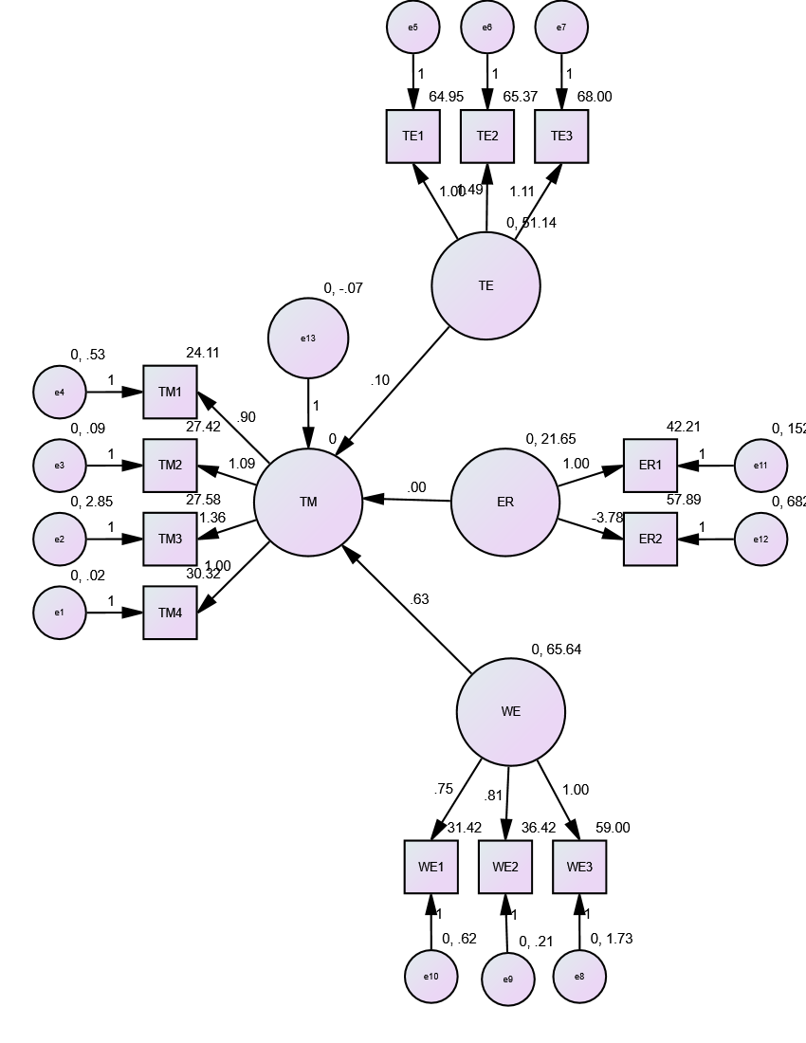
Figure 1. Model of the Predictors of Iranian EFL Teachers’ TM
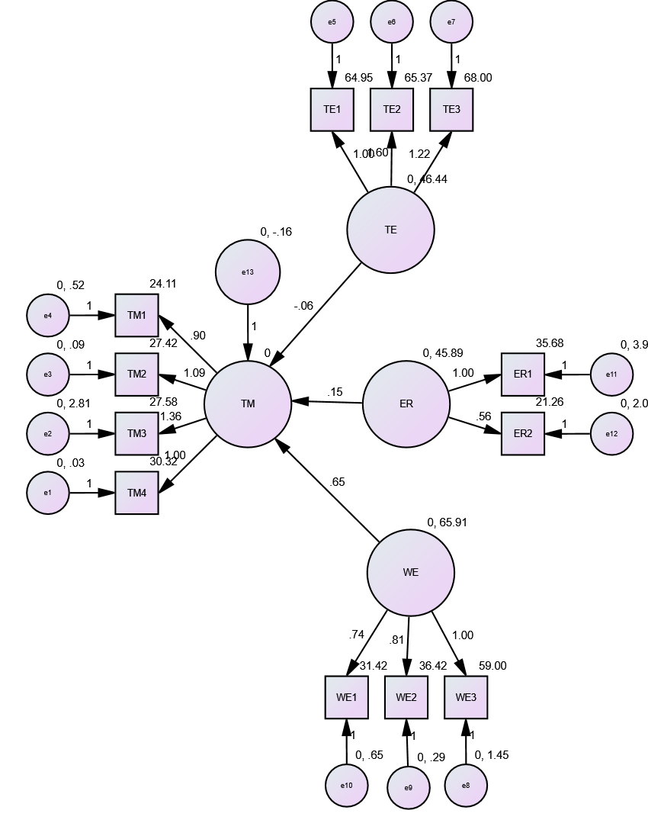
Figure 2. Model of the Predictors of Iranian EFL Teachers’ TM

Figure 3. German and Iranian Teachers’ TM

Conclusion

The present study strived to determine the main predictors of German and Iranian teachers’ TM. Moreover, it examined the difference between the TM of these groups of language teachers. Based on the results, while German teachers’ TE and WE were the main factors in their TM, Iranian teachers’ ER and WE constituted the significant predictors of their TM in their settings.
It is possible to draw a number of conclusions based on these results. First, EFL syllabus designers have to provide the language teachers with effective teaching manuals that provide them with adequate information on their main factors including their TM and make them aware of the consequential role of the relevant factors in their language teaching. The need for these manuals becomes more apparent in the case of Iranian teachers. The relevant manuals have to empower the teachers to use efficient stress-management strategies. Moreover, they should enable them to capitalize on their internal resources, including their ER, WE, and TE in order to deal with the stress-inducing factors in the process of second language instruction.
Second, there is a need to redress the current teacher education courses in the EFL contexts including the Iranian context. The examination of the content of these courses shows that they mainly focus on the practical issues of language instruction and disregard the theoretical issues including teacher variables. Furthermore, most of the teacher educators of these courses do not apprise the teachers of the impact of their variables such as their TM on their instructional efficacy. Considering these issues, it can be argued that it is necessary to add a module to the present teacher education courses that informs the teachers about their affective factors and helps them to capitalize on them to ameliorate their teaching capabilities. In addition, teacher-education course developers have to re-educate the teacher educators in terms of teacher factors to enable them to include teacher-factor-based education in the current courses.
Finally, English teachers have to develop a satisfactory understanding of their own affective variables that influence their teaching practices. Regarding this issue, teachers can attend diverse national and international events such as webinars and education courses to become aware of the affective strategies that can increase their TM and may enable them to deal with sources of stress. Additionally, teachers can take advantage of their peers and supervisors’ support to stifle their negative emotions that decrease their TM and interfere with their effective language teaching.
The present study suffered from certain limitations since the researchers were not able to control the impacts of the participants’ gender, age, language background, and experience on the results. Furthermore, they delimited the study by focusing on German and Iranian teachers’ ER, WE, and TE as predictors of their TM without dealing with the other factors such as their emotional intelligence and spiritual intelligence among the others. The future studies need to deal with these issues. Furthermore, they need to use mixed-methods designs to delve more deeply into the predictors of language teachers’ TM. Finally, these studies have to be conducted in different settings including schools and universities among the others.

Authors Contribution
All authors have contributed equally to prepare the paper.
Availability of data and materials
The data that support the findings of this study are available from the corresponding author, upon reasonable request.
Conflict of interests
The authors declare that they have no known competing financial interests or personal relationships that could have appeared to influence the work reported in this paper.

References

Alexander, C., Wyatt-Smith, C., & Du Plessis, A. (2020). The role of motivations and perceptions on the retention of in-service teachers. Teaching and Teacher Education, 96, 103186.
DOI: https://doi.org/10.1016/j.tate.2020.103186
Ayoobiyan, H., & Rashidi, N. (2021). Can reflective teaching promote resilience among Iranian EFL teachers? A mixed-method design. Reflective Practice, 22(3), 293–305.
DOI: https://doi.org/10.1080/14623943.2021.1873758

Bing, H., Sadjadi, B., Afzali, M., & Fathi, J. (2022). Self-efficacy and emotion regulation as predictors of teacher burnout among English as a foreign language teacher: A structural equation modeling approach. Frontiers in Psychology, 13, 900417.
DOI: https://doi.org/10.3389/fpsyg.2022.900417

Breines, J. G., & Chen, S. (2012). Self-compassion increases self-improvement motivation. Personality and Social Psychology Bulletin, 38, 1133–1143.
DOI: https://doi.org/10.1177/0146167212445599

Burić, I., & Macuka, I. (2018). Self-efficacy, emotions and work engagement among teachers: A two wave cross-lagged analysis. Journal of Happiness Studies, 19(7), 1917–1933.
DOI: https://doi.org/10.1007/s10902-017-9903-9

Burić, I., Sliškovic, A., & Soric, I. (2020). Teachers’ emotions and self-efficacy: A test of reciprocal relations. Frontiers in Psychology, 11, 1650.
DOI: https://doi.org/10.3389/fpsyg.2020.01650

Chang, M. L., & Taxer, J. (2021). Teacher emotion regulation strategies in response to classroom misbehavior. Teachers and Teaching, 27(5), 353–369.
DOI: https://doi.org/10.1080/13540602.2020.1740198

Creswell, J. W., & Creswell, J. D. (2017). Research design: Qualitative, quantitative, and mixed methods approaches (4th ed.). Sage.

Deng, J., Heydarnejad, T., Farhangi, F., & Farid Khafaga, A. (2022). Delving into the relationship between teacher emotion regulation, self-efficacy, engagement, and anger: A focus on English as a foreign language teacher. Frontiers in Psychology, 13, 1019984.
DOI: https://doi.org/10.3389/fpsyg.2022.1019984

Dewaele, J. M., & Li, C. (2022). Foreign language enjoyment and anxiety: Associations with general and domain-specific English achievement. Chinese Journal of Applied Linguistics, 45(1), 32–48.
DOI: https://doi.org/10.1515/cjal-2022-0104

Dewaele, J. M., Witney, J., Saito, K., & Dewaele, L. (2018). Foreign language enjoyment and anxiety: The effect of teacher and learner variables. Language Teaching Research, 22(6), 676–697.
DOI: https://doi.org/10.1177/1362168817692161

Diedrich, A., Grant, M., Hofmann, S. G., Hiller, W., & Berking, M. (2014). Self-compassion as an emotion regulation strategy in major depressive disorder. Behavior Research and Therapy, 58, 43–51.
DOI: https://doi.org/10.1016/j.brat.2014.05.006

Fathi, J., & Derakhshan, A. (2019). Teacher self-efficacy and emotional regulation as predictors of teaching stress: An investigation of Iranian English language teachers. Teaching English Language, 13(2), 117–143.
DOI: https://doi.org/10.22132/TEL.2019.95883

Garg, P., & Rastogi, R. (2009). Effect of psychological well-being on organizational commitment of employees. The IUP Journal of Organizational Behavior, 8(2), 42–51.

Greenier, V., Derakhshan, A., & Fathi, J. (2021). Emotion regulation and psychological well-being in teacher work engagement: A case of British and Iranian English language teachers. System, 97, 102446.
DOI: https://doi.org/10.1016/j.system.2020.102446

Gross, J. J., & John, O. P. (2003). Individual differences in two emotion regulation processes: Implications for affect, relationships, and well-being. Journal of Personality and Social psychology, 85(2), 348–362.
DOI: https://doi.org/10.1037/0022-3514.85.2.348

Klassen, R. M., Yerdelen, S., & Durksen, T. L. (2013). Measuring teacher engagement: Development of the Engaged Teachers Scale (ETS). Frontline Learning Research, 1, 33–52.
DOI: https://doi.org/10.14786/flr.v1i2.44

Li, C., & Li, W. (2022). Anxiety, enjoyment, and boredom in language learning amongst junior secondary students in rural China: How do they contribute to L2 achievement? Studies in Second Language Acquisition, 45(1), 93–108.
DOI: https://doi.org/10.1017/S0272263122000031
Li, M., Heydarnejad, T., Azizi, Z., & Rezaei Gashti, Z. (2022). Modeling the role of emotion regulation and critical thinking in immunity in higher education. Frontiers in Psychology, 13, 1005071.
DOI: https://doi.org/10.3389/fpsyg.2022.1005071

Moradkhani, S., Raygan, A., & Moein, M. S. (2017). Iranian EFL teachers’ reflective practices and self-efficacy: Exploring possible relationships. System, 65, 1–14.
DOI: https://doi.org/10.1016/j.system.2016.12.011

Pallant, J. (2020). SPSS survival manual: A step by step guide to data analysis using IBM SPSS. Routledge.
Proietti Ergün, A. L. P., & Dewaele, J. M. (2021). Do well-being and resilience predict the foreign language teaching enjoyment of teachers of Italian? System, 99, 102506.
DOI: https://doi.org/10.1016/j.system.2021.102506

Proietti Ergün, A. L. P., & Ersoz Demirdag, H. (2022). The relation between foreign language enjoyment, subjective well-being, and perceived stress in multilingual students. Journal of Multilingual and Multicultural Development, 1–13.
DOI: https://doi.org/10.1080/01434632.2022.2057504

Roth, G., Assor, A., Kanat-Maymon, Y., & Kaplan, H. (2007). Autonomous motivation for teaching: How self-determined teaching may lead to self-determined learning. Journal of Educational Psychology, 99, 761–774.
DOI: https://doi.org/10.1037/0022-0663.99.4.761

Shu, K. (2022). Teachers’ commitment and self-efficacy as predictors of work engagement and well-being. Frontiers in Psychology, 13, 850204.
DOI: https://doi.org/10.3389/fpsyg.2022.850204

Skaalvik, E. M., & Skaalvik, S. (2020). Teacher burnout: Relations between dimensions of burnout, perceived school context, job satisfaction and motivation for teaching. A longitudinal study. Teachers and Teaching, 26, 602–616.
DOI: https://doi.org/10.1080/13540602.2021.1913404

Song, J. H., Chai, D. S., Kim, J., & Bae, S. H. (2018). Job performance in the learning organization: The mediating impacts of self-efficacy and work engagement. Performance Improvement Quarterly, 30(4), 249–271.
DOI: https://doi.org/10.1002/piq.21251

Soodmand Afshar, H., & Moradifar, M. (2021). The structural interplay between critical cultural awareness, institutional identity, self-efficacy, reflective teaching and job performance of EFL teachers. International Journal of Society, Culture & Language, 9, 14–29.

Stapleton, P., Garby, S., & Sabot, D. (2020). Psychological distress and coping styles in teachers: A preliminary study. Australian Journal of Education, 64(2), 127–146.
DOI: https://doi.org/10.1177/0004944120908960

Stavraki, C., & Karagianni, E. (2020). Exploring Greek EFL teachers’ resilience. Journal for the Psychology of Language Learning, 2, 142–179.
DOI: https://doi.org/10.52598/jpll/2/1/7

Tao, J., Zhao, K., & Chen, X. (2019). The motivation and professional self of teachers teaching languages other than English in a Chinese university. Journal of Multilingual and Multicultural Development, 40, 633–646.
DOI: https://doi.org/10.1080/01434632.2019.1571075

Xiao, Y., Fathi, J., & Mohammaddokht, F. (2022). Exploring a structural model of teaching enjoyment, teacher self-efficacy, and work engagement. Frontiers in Psychology, 13, 3384.
DOI: https://doi.org/10.3389/fpsyg.2022.918488

Xiaojing, X., Badakhshan, E., & Fathi, J. (2022). Exploring teacher reflection in the English as a foreign language context: Testing factor structure and measurement invariance. Frontiers in Psychology, 12, 6708.
DOI: https://doi.org/10.3389/fpsyg.2021.828901

Xiyun, S., Fathi, J., Shirbagi, N., & Mohammaddokht, F. (2022). A structural model of teacher self-efficacy, emotion regulation, and psychological well-being among English teachers. Frontiers in Psychology, 13, 904151.
DOI: https://doi.org/10.3389/fpsyg.2022.904151

Yang, C., Chan, M. K., Nickerson, A. B., Jenkins, L., Xie, J. S., & Fredrick, S. S. (2022). Teacher victimization and teachers’ subjective well-being: Does school climate matter? Aggressive Behavior, 48(4), 379–392.
DOI: https://doi.org/10.1002/ab.22030

Yuan, R., & Zhang, L. J. (2017). Exploring student teachers’ motivation change in initial teacher education: A Chinese perspective. Teaching and Teacher Education, 61, 142–152.
DOI: https://doi.org/10.1016/j.tate.2016.10.010

Zeng, G., Chen, X., Cheung, H. Y., & Peng, K. (2019). Teachers’ growth mindset and work engagement in the Chinese educational context: Well-being and perseverance of effort as mediators. Frontiers in Psychology, 10, 442256.
DOI: https://doi.org/10.3389/fpsyg.2019.00839

Biodata

Farnoush Ahangaran, an Assistant Professor at Urmia Azad University, Iran, holds a PhD in English Language Teaching (ELT) with 25 years of teaching experience. He has supervised and examined numerous MA theses and currently teaches ELT courses at the BA and MA levels, as well as specialized online courses. A TESOL-certified educator, Dr. Ahangaran is highly dedicated to English Language Teaching.

Aram Pouyan, an Assistant Professor, holds a PhD in English Language Teaching (ELT) with over 17 years of teaching experience. She has taught ELT courses at BA level as well as online for many years. A TESOL-certified educator, Dr. Pouyan is highly professional in English Language Teaching.

