
pp. 1:6
Optimal Capacitor Placement to Improve the Performance of the Electrical Power Distribution System Using Genetic Algorithm
Mohammad Hossein Kafi^{1,3}, Mehdi Mahdavian*², Ali Asghar Amini^{1,3}, Ghazanfar Shahgholian^{1,3}, Majid Dehghani^{1,3}
¹ Department of Electrical Engineering, Najafabad Branch, Islamic Azad University, Najafabad, Iran
²Department of Electrical Engineering, Naein Branch, Islamic Azad University, Naein, Isfahan, Iran, meh_mahdavian@yahoo.com
³Smart Microgrid Research Center, Najafabad Branch, Islamic Azad University, Najafabad, Iran
Abstract
The purpose using capacitors in distribution networks is to reduce the total losses of the network. Capacitors help regulate the power factor and voltage in the electrical distribution system, and can be controlled remotely, in and out of the system. Capacitor placement depends on the objective function, which is usually single-objective or multi-objective. In this paper, the amount of capacitor at minimum load is determined using a genetic algorithm. The calculation is done at peak load to determine the sensitivity of power losses. By using this method, the increase of the voltage caused by the lead phase of the system is prevented in the minimum load. A multi-purpose objective function to simultaneously reduce losses and improve the voltage profile of the optimal capacitor size in each section is detected by a genetic algorithm. To show the efficiency of the method, the capacitor placement results are compared using DIGSIENT software.
Keywords: Capacitor Placement, Genetic Algorithm, Performance Improvement, Power Sensitivity Coefficient.
Article history: Received 20-Apr-2021; Revised 01-May-2021; Accepted 15-May-2021.
© 2021 IAUCTB-IJSEE Science. All rights reserved

- Introduction

The development of transmission systems is important in power grids due to the increasing demand load [1-9]. The distribution system is the interface between the bulk power system and the consumers. The distribution system is part of an electrical power system after the transmission system. Delivery of electrical energy to consumer places is its task [10-13]. Radial distribution system has many applications due to its low cost and simple design [14,15]. When moving away from the substation, the voltage of the buses decreases proportionally and the losses increase secondarily due to the lack of reactive power required [16,17]. Therefore, capacitors are used, and placing the capacitor in the right size is an important issue [18-20]. So far, various studies have been performed to determine the optimal location of the capacitor, which aims to reduce power losses and improve the system voltage profile [21-28].
The problem of simultaneous selection of the optimal location and size of shunt capacitors in three-phase unbalanced radial distribution systems is investigated in [29], which, the main objective function formulated by the two terms energy loss cost, and the cost of capacitor purchase and capacitor installation, is formed. Has been. Finally, the simulation results of the 25-bus unbalanced radial distribution systems and the 37-bus IEEE are shown.
A two-step method, including loss sensitivity analysis using two sensitivity indicators, and minimization of the objective function using the ant colony optimization algorithm, is proposed to identify the optimal locations and capacitance sizes in radial distribution systems in [30].
An analytical method for locating the shunt capacitor optimally in power systems in [31] is presented to achieve the most stable conditions as well as to minimize network losses. Where the modal analysis technique is modified and a new formula is created to calculate the reactive contribution Index of each freight bus based on the inverted reduced Jacobin matrix.
In [32] the ant colony optimization met heuristic is used for minimize the total active losses in electrical distribution systems by means of optimal capacitor bank placement.
A method for solving the capacitor placement problem to determine the minimum required investment is proposed to satisfy the appropriate response constraints in [33], in which a combined method of two algorithms is considered.
A genetic algorithm for optimum shunt capacitor placement in micro-grids in distribution networks with consideration of islanded mode of operation is proposed in [34], which the cost function of the proposed optimization technique consists of three terms the cost of power and energy losses, the cost of capital investments of the installed shunt capacitors and the customers cost of interruption.
A computationally efficient methodology for the optimal location and sizing of static and switched shunt capacitors in radial distribution systems proposed in [35], which this method selects the nodes to be compensated, as well as the optimal capacitor ratings and their operational characteristics.
To minimize total power losses and capacitor installation costs, the optimal capacitor placement problem in a radial distribution system using the flower pollination algorithm in [36] is proposed, in which the power flow and network losses with The use of load flow analysis is obtained in data structures.
The water cycle algorithm for placing and optimizing the size of distributed generation units and capacitor banks in [37] is presented to increase system performance, which has different objectives such as minimum power loss, voltage deviation and total energy cost.
To solve the problem of placement and size of shunt capacitors, it proposes optimal radial distribution systems in [38] based on loss sensitivity factors correction. Then, the multiverse optimizer is used to simultaneously search for the most optimal bus passes and the corresponding capacitor sizes, and then to evaluate the effectiveness of the developed approach, the simulation results on 10, 33 and 69 bus radial distribution systems are shown.
The purpose of this paper is to improve the voltage profile and active power losses by placing a capacitor in the distribution system. The amount of capacitor is measured using loss sensitivity analysis and genetic algorithm. The power dissipation sensitivity coefficient for each section provides an important information feed, which is determined using a load flow study. In a feeder, the parts with the highest power dissipation sensitivity are selected to install the capacitor. A multi-purpose objective function to simultaneously reduce losses and improve the voltage profile of the optimal capacitor size in each section is detected by a genetic algorithm. DIGSILENT software has been used to show the simulation results of capacitor installation effect.
- The system under study
The system studied in this paper is the radial feeder shown in Figure 1. This feeder is very long and the voltage drop and power drop is high. The physical and electrical characteristics of the feeder are presented in Tables 1 and 2 [39].

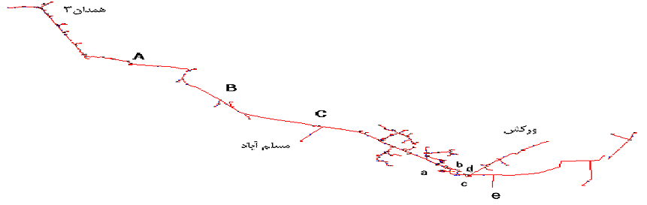
- Geographical diagram of Nasher feeder
- Research method and simulation results
By changing the load or system specifications, the amount of losses can be changed, and at the same time the voltage profile can be improved.

Physical specifications of Nasher feeder
Name | Nashar
Length (m) | 87050
Length of right way (m) | 46135
Number of section | 186
Number of indoor transformer | 0
Number of outdoor transformer | 87

Electrical specifications of Nasher feeder
Parameters | Values
Voltage | 20 KV
Active power | 4184 KW
Minimum voltage | 15.512 KV
Active power losses | 577 KW
Current | 149.22 A
Power factor | 0.809
Percentage of voltage droop | 22.44%
Percentage of active power | 13.79%

Optimal capacitor placement in distribution systems has a number of advantages such as reducing losses, improving voltage profile, improving power factor and so on.
- Genetic Algorithm:
A genetic algorithm is an algorithm that mimics the natural selection process, and is used to solve finite optimization problems [40,41]. The main differences between the genetic algorithm and the classical optimization methods are the following:
1. GA works on the encoded strings of the problem parameters. The real quantities of the parameters are obtained from the decoding of these strings.
2. GA searches for different response spaces simultaneously, and reduces the likelihood of getting caught in locally optimized points.
3. In a genetic algorithm, only one response function, called the fit function, needs to be computed. This function expresses the degree of proximity of the response to the objective function of the algorithm.
- Capacitor Placement Method:
The steps of capacitor placement method using genetic algorithm are:
(1) Formation of the initial population based on candidate buses.
(2) Evaluate each chromosome in four steps, which are:
(a) Installing the capacitors identified by each of the chromosomes on the candidate buses,
(b) Performing reciprocal load distribution operations,
(c) Calculate the rate of power drop and voltage profile,
and (d) determine a certain value as the degree of competence of the chromosome to it.
(3) Build new populations based on transfer, crossover and mutation operations.
(4) Repeat steps 2 and 3 until the stop parameter is reached, which can be the maximum number of repetitions.
(5) Determine the amount of capacitor required by decoding each of the chromosomes.
The capacitor placement algorithm is show in Fig. 1.
- Simulation results:
First, the capacitors are placed in the distribution feeder. Then the operation of placing the capacitor on this feeder is done by DIGSILENT software. After placing the capacitor with the genetic algorithm in the feeder of the publisher, and performing load distribution operations with reciprocal approach, and calculating the power drop rate and voltage profile, the critical points are identified according to the losses and voltage droop.
The critical part of this feeder are A, B and C. The capacitor values determined for each location for the purpose of the genetic algorithm, and the amount of power loss in each critical section before and after capacitor placement, are shown in Figure 2. The results are also shown in Table 3. The capacitor in each bank is 125 KVAR.
By simulation of Nasher feeder using DIGSILENT software, specifying capacitors placement of 130, 250, 480, 1000, and 30 KVAR, this software specifies the places as a, b, c, d, and e. The capacitor for each of place is presented in Table 4.
By exercising the results of the algorithm and the software as well as installing the specified capacitors in the specified and critical sections by the software, the feeder parameters are changed according to Figures. 3. The results are also shown in Table 5.

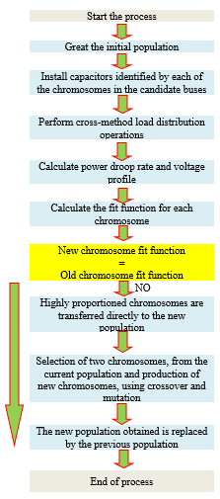
- Capacitor placement algorithm

- The capacitor size required in each section

- The specification of the feeder before and after capacitor placing

Capacitor size required in each section
Section name | Capability of installed capacitor (KVAR) | Power losses before capacitor placement In each section (KW) | Power losses after capacitor placement In each section (KW)
A | 125 | 27.78 | 18.25
B | 250 | 69.89 | 46.49
C | 750 | 49.3 | 33.95

The specification of the feeder before and after capacitor placing
Section name | a | b | c | d | e
Capability of capacitor (KVAR) | 1000 | 480 | 250 | 130 | 30

The specification of the feeder before and after capacitor placing
specification | Before capacitor placement | after capacitor placement by intelligent method | after e capacitor placement by DIGSILENT software
Current in head of feeder (A) | 149.27 | 119.64 | 116.31
Voltage (kV) | 15.509 | 17.3 | 17.87
Power factor | 0.809 | 0.991 | 0.982
Power losses in feeder (kW) | 577 | 391 | 347

In figs. 5, 6 and 7, the voltage profile before and after capacitor placement using two methods are depicted.

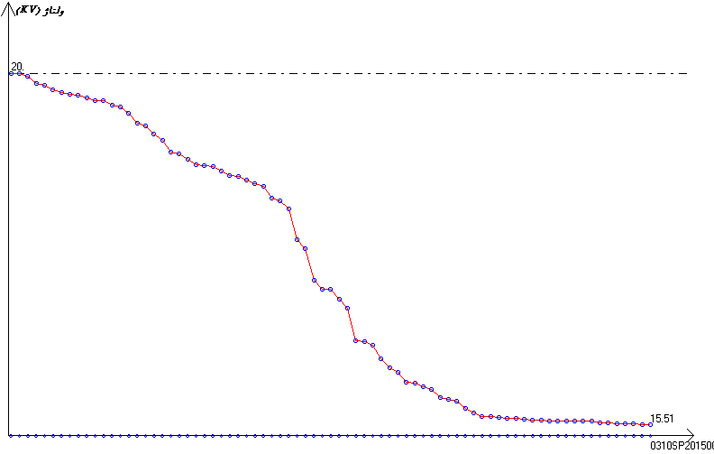
- The Nasher feeder voltage profile before placing the capacitor
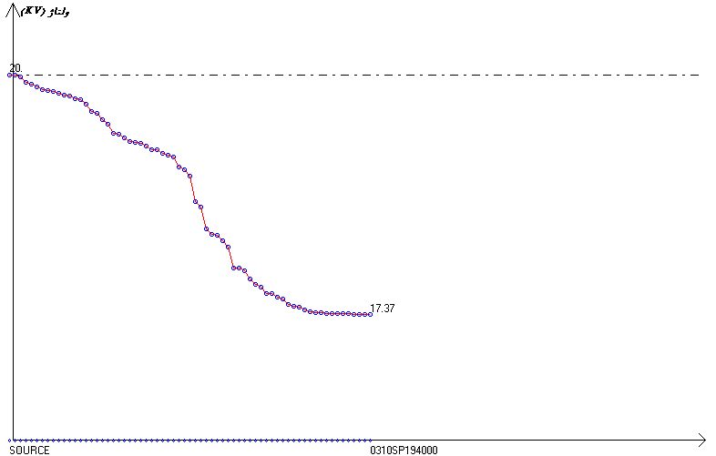
- Nasher voltage feeder profile after placing the capacitor by intelligent method
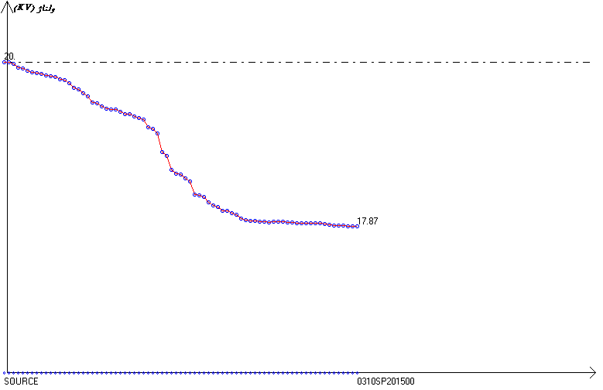
- Nasher feeder voltage profile after placing the capacitor by DIGSILENT software
- Conclusions
The use of capacitors in distribution networks, and their optimal location in the distribution system, is an important and fundamental necessity. A multifunctional objective function, for simultaneous improvement of several parameters, in determining the capacitance size, is proposed in this paper, which is solved using a genetic algorithm.
The installation location of the fixed capacitor was obtained by the fast load distribution method, which is a reciprocal method. The algorithm is implemented on a very long radial feeder, which results in a significant reduction in losses, and a relative improvement in voltage and power quality profiles. With the reduction of losses, part of the line capacity was freed up, and finally the costs of developing new resources were reduced. Also, with the relative improvement in the quality of the voltage profile, the quality of the power supply also increased.
By comparing the results of placing the capacitors intelligently using DIGSILENT software, it was shown that the presentation method has more economic advantages than the software method, because the software while creating more improveement in losses and voltage profiles, but more capacitors are used that are not cost effective.
References
- A. Hamidi, J. Beiza, T. Abedinzade, A. Daghigh, “Improving the dynamic stability of power grids including offshore wind farms and equipped with HVDC transmission system using adaptive neural controller”, Journal of Intelligent Procedures in Electrical Technology, vol. 11, no. 42, pp. 79-99, September 2020.
- B. Fani, M. Dadkhah, A. Karami, “Adaptive protection coordination scheme against the staircase fault current waveforms in PV-dominated distribution systems”, IET Generation, Transmission and Distribution, vol.12, no. 9, May 2018.
- N. Taheri, H. Orojlo, F. Ebrahimi, "Damping controller design in offshore wind power plants to improve power system stability using fractional order PID controllers based on optimized exchange market algorithm", Journal of Intelligent Procedures in Electrical Technology, vol. 13, no. 51, pp. 91-110, Dec. 2022.
- S. Zanjani, Z. Azimi, M. Azimi, “Assesment and analyze hybride control system in distribution static synchronous compensator based current source converter”, Journal of Intelligent Procedures in Electrical Technology, vol. 2, no. 7, pp. 59-67, Dec. 2011.
- B. Fani, F. Hajimohammadi, M. Moazzami, M. J. Morshed, “An adaptive current limiting strategy to prevent fuse-reclosermiscoordination in PV-dominated distribution feeders”, Electric Power Systems Research, vol. 157, pp. 177-186, 2018
- E. Abbaspour, B. Fani, E. Heydarian-Forushani, “A bi-level multi agent based protection scheme for distribution networks with distributed generation”, Int. Journal of Electrical Power and Energy Systems, vol. 112, pp. 209-220, Nov. 2019
- B. Kroposki, “Integrating high levels of variable renewable energy into electric power systems”, Journal of Modern Power Systems and Clean Energy, vol. 5, pp. 831–837, 2017.
- Y. Chen, S. Pan, M. Huang, Z. Zhu, Y. Liu, X. Zha, "MMC-MTDC transmission system with partially hybrid branches", CES Transactions on Electrical Machines and Systems, vol. 5, no. 2, pp. 124-132, June 2021.
- X. Zhu, J. Wang, N. Lu, N. Samaan, R. Huang, X. Ke, "A hierarchical VLSM-based demand response strategy for coordinative voltage control between transmission and distribution systems", IEEE Trans. on Smart Grid, vol. 10, no. 5, pp. 4838-4847, Sept. 2019.
- H. Fayazi, B. Fani, M. Moazzami, G. Shahgholian, “An offline three-level protection coordination scheme for distribution systems considering transient stability of synchronous distributed generation”, Int. Journal of Electrical Power and Energy Systems, Vol. 131, Article Number: 107069, Oct. 2021.
- A. Águila Téllez, G. López, I. Isaac, J.W. González, “Optimal reactive power compensation in electrical distribution systems with distributed resources. Review”, Heliyon, vol. 4, no. 8, Article Number: e00746, Aug. 2018.
- G. Upadhyay, R. Saxena, G. Joshi, "Optimal capacitor placement and sizing in distribution system using hybrid approach of PSO-GA", Proceeding of the IEEE/ICAETGT, pp. 1-6, Coimbatore, Sept. 2017.
- K. Sun, Q. Chen, Z. Gao, "An automatic faulted line section location method for electric power distribution systems based on multisource information", IEEE Trans. on Power Delivery, vol. 31, no. 4, pp. 1542-1551, Aug. 2016.
- A. Chaturvedi, K. Prasad, R. Ranjan, "Use of interval arithmetic to incorporate the uncertainty of load demand for radial distribution system analysis", IEEE Trans. on Power Delivery, vol. 21, no. 2, pp. 1019-1021, April 2006.
- W. Wang, S. Jazebi, F. de León, Z. Li, "Looping radial distribution systems using superconducting fault current limiters: feasibility and economic analysis", IEEE Trans. on Power Systems, vol. 33, no. 3, pp. 2486-2495, May 2018.
- R. Roshanfekr, M. Dostfateme, H. Sadoghi Yazdi, “ACO algorithm implementation in radial distributed network planning”, Journal of Intelligent Procedures in Electrical Technology, vol. 1, no. 3, pp. 27-36, Dec. 2010.
- H. Ezati, S. Yazdian Varjani, “Using parallel active power filter based on voltage detection on a radial distribution feeder with the aim of reducing the harmonic propagation and whack-a-mole phenomena”, Journal of Intelligent Procedures in Electrical Technology, vol. 3, no. 11, pp. 27-40, Sept. 2013.
- A Kiani, B. Fani, G Shahgholian, “A multi-agent solution to multi-thread protection of DG-dominated distribution networks”, Int. Journal of Electrical Power and Energy Systems, vol. 130, Article Number: 106921, Sept. 2021.
- S.A. Hashemi-Zadeh1, O. Zeidabadi-Nejad, S. Hasani, A.A. Gharaveisi, G. Shahgholian, "Optimal DG placement for power loss reduction and improvement voltage profile using smart methods", Int. Journal of Smart Electrical Engineering, Vol. 1, No. 3, pp. 141-147, Summer 2012.
- R.A. Gallego, A.J. Monticelli, R. Romero, "Optimal capacitor placement in radial distribution networks", IEEE Trans. on Power Systems, vol. 16, no. 4, pp. 630-637, Nov. 2001.
- M. Salari, F. Haghighatdar-Fesharaki, “Optimal placement and sizing of distributed generations and capacitors for reliability improvement and power loss minimization in distribution networks”, Journal of Intelligent Procedures in Electrical Technology, vol. 11, no. 43, pp. 83-94, Dec. 2020.
- H.D. Chiang, J.C. Wang, J. Tong, G. Darling, "Optimal capacitor placement, replacement and control in large-scale unbalanced distribution systems: modeling and a new formulation", IEEE Trans. on Power Systems, vol. 10, no. 1, pp. 356-362, Feb. 1995.
- A. Ahmadpour, H. Shayeghi, E. Mokaramian, “Investigation of capacitor placement in variable loads to reduce the power loss of distribution systems using mixed–integer linear programming algorithm and re–gradation of loads”, Journal of Intelligent Procedures in Electrical Technology, vol. 9, no. 36, pp. 51-61, March 2019.
- H. Lotfi, M. Elmi, S. Saghravanian, “Simultaneous placement of capacitor and DG in distribution networks using particle swarm optimization algorithm”, Int. Journal of Smart Electrical Engineering, vol. 7, no. 1, pp. 35-41, Winter 2018.
- C. Chung-Fu, "Reconfiguration and capacitor placement for loss reduction of distribution systems by ant colony search algorithm", IEEE Trans. on Power Systems, Vol. 23, No. 4, pp. 1747-1755, Nov. 2008.
- J.F.V. González, C. Lyra, F.L. Usberti, “A pseudo-polynomial algorithm for optimal capacitor placement on electric power distribution networks”,European Journal of Operational Research, vol, 222, no. 1, pp. 149-156, 2012.
- M. Mohammadnia, A. Gharaveisi, “Joint network reconfiguration and capacitor placement by bactrial foraging algorithm”, Journal of Intelligent Procedures in Electrical Technology, vol. 1, no. 4, pp. 11-16, March 2011.
- H.E.Z. Farag, E.F. El-Saadany, "Optimum shunt capacitor placement in multimicrogrid systems with consideration of islanded mode of operation", IEEE Trans. on Sustainable Energy, Vol. 6, No. 4, pp. 1435-1446, Oct. 2015.
- J.B.V. Subrahmanyam, C. Radhakrishna, “A simple method for optimal capacitor placement in unbalanced radial distribution system”, Electric Power Components and Systems, vol. 38, no. 11, pp. 1269-1284, Sept. 2010.
- A.A.A. El-Ela, R.A. El-Sehiemy, A.M. Kinawy, M.T. Mouwafi, “Optimal capacitor placement in distribution systems for power loss reduction and voltage profile improvement”, IET Generation, Transmission and Distribution, vol. 10, no. 5, pp. 1209-1221, April 2016.
- A. Arief, Antamil, M.B. Nappu, “An analytical method for optimal capacitors placement from the inversed reduced jacobian matrix”, Energy Procedia, vol. 100, pp. 307-310, 2016.
- M.C. Pimentel Filho, E.G.M. Lacerd, M. F. Medeiros Junior, "Capacitor placement using ant colony optimization and gradient", Proceeding of the IEEE.ISAP, pp. 1-4, Curitiba, Brazil, Nov. 2009.
- M. Delfanti, G.P. Granelli, P. Marannino. M. Montagna, "Optimal capacitor placement using deterministic and genetic algorithms", IEEE Trans. on Power Systems, vol. 15, no. 3, pp. 1041-1046, Aug. 2000.
- M. Sedighizadeh, M. Dakhem, M. Sarvi, H. Hosseini-Kordkheili, "Optimal reconfiguration and capacitor placement for power loss reduction of distribution system using improved binary particle swarm optimization", Int. Journal of Energy and Environmental Engineering, Vol. 73, No. 2, pp. 1-11, April 2014.
- H.M. Khodr, Z. Vale, C. Ramos, "Notice of violation of IEEE publication principles: Optimal cost-benefit for the location of capacitors in radial distribution systems", IEEE Trans. on Power Delivery, vol. 24, no. 2, pp. 787-796, April 2009.
- V. Tamilselvan, T. Jayabarathi, T. Raghunathan, X.S. Yang, “Optimal capacitor placement in radial distribution systems using flower pollination algorithm”, Alexandria Engineering Journal, vol. 57, no. 4, pp. 2775-2786, Dec. 2018.
- A.A.A. El-Ela, R.A. El-Sehiemy, A.S. Abbas, "Optimal placement and sizing of distributed generation and capacitor banks in distribution systems using water cycle algorithm", IEEE Systems Journal, vol. 12, no. 4, pp. 3629-3636, Dec. 2018.
- T.P.M. Mtonga, K.K. Kaberere, G.K. Irungu, "Optimal shunt capacitors’ placement and sizing in radial distribution systems using multiverse optimizer", IEEE Canadian Journal of Electrical and Computer Engineering, vol. 44, no. 1, pp. 10-21, Winter 2021.
- M. Mahdavian, M.H. Kafi, A. Movahedi, M. Janghorbani, "Improve performance in electrical power distribution system by optimal capacitor placement using genetic algorithm", Proceeding of the IEEE/ECTI-CON, pp. 749-752, Phuket, Thailand, June 2017.
- A. Najar Khoda Bakhsh, M. Moradian, L. Najar Khodabakhsh, N. Abjadi, “Stabilization of electromagnetic suspension system behavior by genetic algorithm”, Journal of Intelligent Procedures in Electrical Technology, vol. 3, no. 11, pp. 53-61, Sept. 2013.
- E. Aghadavoodi, G. Shahgholian, "A new practical feed-forward cascade analyze for close loop identification of combustion control loop system through RANFIS and NARX", Applied Thermal Engineering, Vol. 133, pp. 381-395, March 2018.

